**An Index for Quantifying Geometric Point Disorder in Geospatial Applications**

S. Jones1[1]* and H.G. Momm1[2]

1Department of Geosciences, Middle Tennessee State University, Murfreesboro, Tennessee

*corresponding author: rj3h@mtmail.mtsu.edu

**Abstract:**

Many techniques have been developed to quantify different conceptualizations of self-interaction and patterns within spatial data. We propose a new metric and related algorithm that describes the geometric spatial disorder of geographic point sets, the “Index of Disorder” (IoD). The IoD algorithm was applied to synthetic and natural datasets and was shown to be able to differentiate between areas of high spatial disorder (randomly placed points) and low spatial disorder (e.g., curvilinear grids, wallpaper groups, and other repeating patterns). Because the IoD is a quantitative metric, it can be used on its own as an aid for identifying areas of unusually high or low spatial disorder or as enrichment for machine learning classification algorithms.

**Keywords:**

Point Patterns; Classification; Homogeneity, Algorithms; Forestry, Planning; Data Processing

**One Sentence Summary:**

The spatial disorder of any arbitrary point in a set of points can be quantified by comparing the relative positions of that point’s neighbors to the relative positions of its neighbors’ neighbors.

# Introduction

The acquisition of large amounts of spatial data has generated the need for automated methods to convert this data into usable information. A significant number of established methods for pattern detection are available, such as spatial autocorrelation, outlier detection, clustering, hotspot detection, and regression (Shekhar, et al., 2011)*.* However, there is a relative scarcity of methods for the analysis and identification of patterns purely comprised of the relationships of the coordinate positioning of points of geospatial data. Such “geometric patterns” are evident in the locational structure of many types of geospatial data, such as the neatly ordered placement of trees in an orchard or house centroids in a planned development. Geometric order contrasts with the relative disorder of naturally occurring features, which display little to no geometric structure as result of the relatively random positioning of each element. This structure, or lack of structure, is often immediately apparent to human investigators, yet is surprisingly difficult to define mathematically (Antuono, et al., 2014), and so there is a relative dearth of methods that can be used to analyze geometric patterns in geospatial contexts.

For example, land cover classification is one of the most widely used and accepted applications of geospatial technologies. Land cover classification studies have been conducted using a wide array of data sources, mostly raster grids derived from imagery (Lou, et al., 2016; Phiri & Morgenroth, 2017). The majority of landcover studies treated individual pixels as isolated data points, ignoring the information contained in the spatial relationships between pixels. Different methods have been developed to discriminate between features based on image texture and the frequency of tonal changes based on pre-determined texture operators (Momm, et al., 2009). Haralick textures were among the first proposed metrics that quantified the spatial relationships between adjacent pixels (Haralick, et al., 1973), and have since been used to increase the accuracy of land cover classification studies (Momm, et al., 2009). Subsequent developments, such as so-called contextual classification methods, further sought to quantify the information contained within spatial pixel-neighbor relationship (Swain & Stephen B. Vardman, 1981). Quantification of lacunarity (self-similarity) has also been used as a way to quantify scale-dependent heterogeneity in raster imagery as a way to aid differentiation of ordered and disordered land use (Dong, 2000). Additional work has shown that textural periodicity is suggestive of certain landcover types (Trias-Sanz, 2006). Over time, a number of additional quantitative metrics of landcover textures and patterns have been developed as well (Remmel & Csillag, 2003). Each of these methods extracts some meaning from the spatial relationships of data, but they are not suited for the detection of geometric patterns: each method is merely a statistical operator on a windowed subset of data, which inherently preserves some information about spatial relationships, but the information about the positioning of data points within the subset is ignored.

Furthermore, because imagery and elevation models are most easily represented as raster datasets, the bulk of methods developed to quantify spatial textures and patterns in geospatial contexts are applicable to raster grid data only. Yet not all geographic information can or should be represented as raster data, such as the coordinate locations of discrete features of interest. In disciplines like spatial statistics, spatial point patterns are quantified using a variety of methods. Intensity methods, such as quadrant count and kernel estimation provide a global idea of sampling intensity but they are sensitive to spatial scale and therefore disregard point spatial pattern as scales smaller than the spatial scale selected (Bailey and Gatrell, 1995 and Lloyd, 2010). Alternatively, methods based on nearest-neighbor distances, such as even-event, point-event and reduced second moment measure (K function), can be used to compare observed with random point pattern, but they still provide only a global measure of the point pattern in comparison with complete spatial randomness (Bailey and Gatrell, 1995). Extensive work has been done on the development of algorithms for detecting regularly repeating structures in point clouds, but these methods have been primarily applied in non-geographic contexts (Pauly, et al., 2008). Additionally, these algorithms do not make an attempt to quantify the level of regularity of individual points in the point cloud even though the regularity of the point cloud is detected quantitatively. Antuono and otherssuggested an algorithm to quantify disorder within simulated fluid-particle systems, but this algorithm makes the assumption that disorder is defined as the deviation from a grid-like structure, an assumption that is likely valid for fluid simulations but fails in the context of geographic systems where order and disorder might be more loosely defined (Antuono, et al., 2014). Because of this, geometric patterns of geospatial data typically ignored, and there is a deficit of methods that can quantify the disorder of geospatial point data without relying on *a priori* assumptions about what patterns constitute “order”.

To quantify the geometric order/disorder of geospatial point datasets, a new metric and related algorithm is described. The proposed metric, referred to as “Index of Disorder” (IoD), quantitatively describes the relative geometric spatial order/disorder of geographic point sets. Calculation and assignment of an IoD score to each point allows the identification of areas of relatively high or low point pattern disorder. Up until this point, such a quantitative measure of geometric disorder in point sets has not been described for use in geospatial contexts, and thus the IoD provides a way to enrich the analysis of such point sets by creating a novel predictor for each individual point which is spatial variable . The main objectives of this study are three-fold: (1) describe the IoD assumptions, parameters, and calculation, (2) discuss the interpretation of IoD scores, and (3) assess the IoD’s performance through its application to synthetic and natural geospatial datasets.

# Methods

## Algorithm Description

The IoD detects structure in the spatial organization of point sets by comparing “neighborhoods” of points to one another. A neighborhood is defined as the set of all points, or “neighbors”, within a given distance of a parent point. By superimposing one neighborhood over another, correspondence is assigned between each point in one neighborhood to a point in the other. A bulk measure of the representative deviation between point-pairs is used to calculate the “IoD subscore” of the neighborhood comparison, where a low average deviation results in a low IoD subscore and indicates that the two neighborhoods are geometrically similar. To calculate the IoD for a given parent point, the IoD subscore calculation is performed between a parent point and every neighbor’s neighborhood; the IoD for the parent point is simply the mean of these IoD subscores. A low IoD then indicates that the spatial patterning in a given area is relatively homogenous, while a high IoD indicates a relative lack of spatial structure. Pseudocode describing the calculation of the IoD is given in *Figure 1*.

A visual depiction of the calculation of the IoD sub-score between two points p1 and p2, which are part of the set of points P, is given in Figure 1. A parent point p1 is defined (red point in Figure 2A) and its neighbors N1 selected based on user-provided threshold distance (Figure 2B). Similarly, a neighbor point p2 is selected and its neighbors N2 (blue points in Figure 2C) are selected using the same user-defined distance criterion. The two neighborhoods N1 and N2 are superimposed by transforming their absolute coordinates to a relative coordinate system in which p1 and p2 are located at the origin (Figure 2D) by subtracting the absolute coordinate values of p1 and p2 from all points in their respective neighborhoods. In other words, the relative coordinate system gives the positioning of any given point in terms of its offset from the neighborhood’s parent point.

Folliwng this, each point in N1 is assigned to a unique point in N2 such that an arbitrary cost function for point assignment is minimized (Figure 2E). The quality of this point-pair assignment is quantified by again calculating a cost function for each assignment and taking the mean of these values; this cost function can be (and often is) the same cost function used to make the assignments. The mean value of assignment quality quantifications is the IoD sub-score. The process repeats, recording the sub-score and repeating the operation by selecting a new child point until the sub-score has been calculated for every neighbor (Figure 2F). The IoD sub-score is an intermediate parameter used in the calculation of the IoD for a given point. Once the IoD sub-score is calculated for every child point within the parent point’s neighborhood, the final IoD of the parent point is calculated as the mean of these IoD sub-scores.

A low IoD sub-score implies geometric similarity between the neighborhoods of two particular points. Therefore a low IoD, being the mean of the IoD subscores in a parent point’s neighborhood, implies that the parent point’s neighborhood shows a general geometric similarity to its neighbors neighborhoods, and thus geometric structure, orderedness or homogeneity exists within the vicinity of the parent neighborhood.

Optionally, prior to point pair assignment, it is possible to apply a second coordinate transformation to N2 that further minimizes the cost of point assignment; this is further elaborated on in the discussion on point set realignment in Section 2.1.2.

### Point Pair Assignment

Calculation of the IoD sub-score for two sets of points involves point pair assignment, where every point in one set (neighborhood *N1*) is assigned to a point in the other set (neighborhood *N2*) with one-to-one correspondence. Additionally, a goodness-of-fit metric is calculated for every point-pair assignment that describes how good the assignment is. The objective is to find an optimal set of point-pair assignments such that the average cost of assignment is minimized. The cost function for point-pair assignment is arbitrary. A readily apparent cost function for point-pair assignment is the Euclidean distance between the two members of a point pair, two points that are close together are a more obvious match than those that are far apart. Other cost functions such as the square root of the distance or sigmoidal functions (Figure 3) that relate Euclidean distance to a score are viable as well. Sigmoidal functions are particularly useful since their parameterization allows users to define the distance at which the cost function should begin to increase (Km) and the rapidity with which it should increase (the so-called cooperativity of the function) in addition to imposing well-defined bounds on the range of the function (*Figure 3*).

The assignment of correspondence, or assignment problem, is formulated in such way that there exists a complete bipartite graph composed of two sets of parent and child vertices (Figure *2*E). Each candidate solution connects a parent to a child and has an associated cost $c(i,j)$*.* If the sets are not of equal size, then the graph is incomplete, but the graph can be made complete by adding some number of arbitrary vertices to the smaller set and connecting them to the larger set with an arbitrarily large assignment cost. When a solution is found that minimizes the assignment costs, the arbitrary vertices and edges are removed. Thus, the larger set will have some number of unpaired points.

Solving the assignment problem through brute force implies a time complexity of $O(n!)$*,* where $n$ is the number of points being matched, though many algorithms have been proposed to improve computing efficiency. The point pair assignment algorithm used in this study is the Hungarian method as implemented in the scientific computing library *scipy* (Oliphant, 2006). The Hungarian method solves the assignment problem in polynomial time $O(n^{3})$, (Kuhn, 1955). The algorithm works by reframing the problem as an *n x n* cost matrix *M* where the cost between *Pi* and *Pj* is $c(i,j)$. The solution is the set *S* of *n* entries that minimizes the sum of the set while respecting one-to-one correspondence. The Hungarian algorithm takes advantage of the fact that subtracting a constant from a row or column does not change the set of optimal entries, and so by repeatedly subtracting values from rows and columns the assignment problem can be reduced to a form where some of the matrix entries are 0 (Kuhn, 1955).

It is important to note that the Hungarian method was selected and explained here to solve the assignment problem because it is well-accepted and a ubiquitous solution, however, other algorithms could had been used instead.

### Point Set Realignment

In some cases it may be desirable to realign neighborhoods for better correspondence (point sets registration) if it is suspected that spatial patterns in the data may become offset, rotated, scaled, or flipped. Existing point registration methods require a cost function to evaluate candidate solutions. In this study, the same cost function described for point pair assignment was used in the point set realignment.

Although multiple methods are available, and any of them could have been used, the Iterative Closest Point (ICP) method (Besl & McKay, 1992) was selected due to its popularity in solving problems of this sort. The algorithm iteratively registers points by assigning all points in N1 to points in N2 and then finds the least squares of the rigid transformation that minimizes the point-pair assignment cost. The process is repeated until the point-pair deviation falls below a threshold or the algorithm exceeds the pre-determined number of iterations.

### Scoring Function

Once two neighborhoods have been assigned to one another, a function must be defined that relates the displacement between two assigned points with a score describing the quality of the match, which we call the “assignment score” for that point. It is convenient to define a scoring function that has a lower bound of 0 (to describe no disorder) and an upper bound of 1 (to describe maximal disorder), though such a range is arbitrary. Furthermore, using the same function for scoring as used in the point pair assignment ensures that the calculated point correspondence results in the minimum score possible and minimizes the conceptual complexity of the IoD’s calculation.

### Unpaired points

Often neighborhoods being compared do not have the same number of points, resulting in unpaired points during point-pair assignment. Because the distance between a point and its assigned partner is used to calculate the point’s assignment score, a decision must be made regarding how to calculate assignment scores for unpaired points.

The simplest option is to ignore unpaired points when calculating the mean assignment cost. An obvious drawback is that assigning a neighborhood with few points to another with many points could lead to a small IoD despite the fact that no true point correspondence necessarily exists.

A second option is to penalize unmatched points by some arbitrary amount, which would prevent IoD depression when sparse neighborhoods are compared to dense neighborhoods. However, there are some circumstances where two neighborhoods may show the same pattern, but the pattern in one neighborhood is truncated because e.g., the neighborhood’s parent point lies at the edge of a pattern (Figure 4). In this case, penalizing unpaired points would raise the IoD even though true pattern correspondence exists.

A final and generally superior option is to punish unpaired points if and only if they are within the convex hull of the subset of points that have an assignment. This allows for patterns in compared neighborhoods to be of unequal spatial extent while preventing noisy points from reducing the IoD. In the case of 2-dimensional points, this can be visualized as the area enclosed by a rubber band stretched over the assigned set (Figure 4). This was the option adopted for this paper, though it should be noted that this solution performs best of the convex hull is simple and may not perform well for highly irregular patterns with large convexities or topological holes and irregularities.

## Theoretical Evaluation

Synthetically generated patterns and their IoD scores were evaluated (Figure 5). The inner blue circle describes the neighborhood size and the red circle denotes the radius outside of which the pattern becomes increasingly perturbed with noise of increasing strength outside an arbitrary distance from the origin. Thus, the order of the pattern is entirely preserved within the arbitrary radius, but the system becomes increasingly disordered beyond that radius. Multiple patterns were investigated: square grid (Figure *5*A), rectangular grid modified with a sinusoidal function (Figure *5*B), pattern formed by overlaying concentric circles with equal linear point densities (Figure *5*C), pattern formed by overlapping a square grid with a copy of the same grid rotated 45 degrees (Figure *5*D), pattern formed by overlapping two offset rectangular grids (Figure *5*E), pattern formed by overlapping three offset rectangular grids (Figure *5*F).

The IoD for all synthetic datasets were evaluated based on a sigmoidal function for point assignment and assignment scoring. Each synthetic point set was evaluated twice: with and without iterative closest point realignment, but with no other changes to algorithm parameters (Table 1). When ICP realignment was used, the same sigmoidal function used for point assignment and assignment scoring was used to calculate correspondence within the ICP algorithm.

The parameterization of the IoD algorithm for the theoretical evaluation used the following values. The neighborhood search radius of the IoD was set at 15 units. The value at which the sigmoidal scoring function assigns a score of 0.5 (Km) was to set to 3 units. The degree of cooperativity of the sigmoidal scoring function was set to 5. The assignment score (punishment) given to unpaired points was set to 1, but was only applied to unpaired points falling within the convex hull of the set of paired points.

## Applied Evaluations

The IoD was applied to three geospatial datasets, two consisting of tree crown locations and one consisting of building centroids. Each dataset is known to contain at least one area of intrinsic order. The ability of the IoD to differentiate disordered from ordered areas was quantified using Cohen's kappa coefficient (κ) of agreement and overall accuracy metrics. Continuous IoD values were classified into two classes of “ordered” or “disordered” by defining a IoD threshold value in which individual points would be assigned to class “disordered” if their IoD was at or above that threshold, and to class “ordered” otherwise. A IoD threshold value was selected for each study site based on quantitative comparison with manually generated reference datasets. Once the IoD threshold was selected, a sensitivity analysis was then conducted to determine the optimal neighborhood radius *r* and *Km* for each study site-threshold value combination.

### Tree Crowns

Three-dimensional point clouds derived from LiDAR (Light Detection and Ranging) were acquired from United States Geological Survey’s (USGS) National Map repository for two study areas. The LiDAR-processing software suite LAStools was used to generate multiple rasterized elevation models (Isenburg, 2019). Tree crowns were automatically extracted using the Laplace of Gaussian blob detection algorithm implemented in the Python package scikit-learn (Pedregosa, et al., 2011), although other methods could had been employed (Zhen, et al., 2016).

#### Site 1 – Apple orchard in TN, USA

For ease of harvest and maintenance, orchards are typically planted in regular patterns that contrast with the disordered distribution of naturally occurring tree stands. The most common planting patterns are grid-based. The predictability of these patterns has allowed for some automated differentiation of orchards from natural tree stands on the basis the textural characteristics of orthoimagery (Aksoy, et al., 2012). However, alternative patterns such has single and double hedged, hexagonal, quincunx and topographically contoured planting systems are also used, limiting identification by standard methods (Khan, et al., 2017).

The IoD was applied to tree crown centroids extracted from a 7.5 km2 area in a small commercial apple orchard in Tennessee, USA. The study area is rural and consists of two distinct planted areas of rectangularly gridded apple trees trending northwest to northeast. Mature natural forest is also present to the west and north of the orchard as well as sparse and isolated naturally occurring trees.

Trees crown centroids were manually classified using both the LiDAR-derived elevation models and contemporaneous aerial imagery. The IoD was calculated for all tree centroids in the study area, and trees were classified as “disordered” if their IoD was above an arbitrary IoD threshold and “ordered” if below the threshold. “Ordered” trees were assumed to correspond to orchard trees and a sensitivity analysis was conducted to characterize the effect that varying the scoring function’s Km and the neighborhood radius has on the classification quality. The cooperativity of the scoring function was held constant at 5 during the sensitivity analysis.

#### Site 2 – Reforested Area in Mooresville, NC

Site 2 is a 0.6 km2 area centered on a partially reforested zone located in Mooresville, NC, USA. The study area is rural and consists of linear rows of young planted trees abutted by older natural mature forest. The trees comprising the replanted areas form roughly rectangular grid patterns of varying orientation that contrast with the disorder of the natural forest.

Like Site 1, trees were manually classified as being part of the replanted zone or not based on LiDAR-derived elevation models and contemporaneous aerial imagery. The IoD was calculated for all trees in the study area, and trees were classified as “disordered” if their IoD was above an arbitrary IoD threshold and “ordered” if below the threshold. “Ordered” trees were assumed to correspond to replanted zones and a sensitivity analysis was conducted to characterize the effect that varying the scoring function’s Km and the neighborhood radius has on the classification quality. The cooperativity of the scoring function was held constant at 3 during the sensitivity analysis.

#### Site 3 – Neighborhood in Nashville, TN

Urban planners have long noted the morphological peculiarities of unplanned or “organic” city growth as compared to those of planned growth. Planned portions of cities are marked by regularity of building placement and street network orientation, while organic growth does not (Nilsson & Gil, 2019; Boeing, 2019). On a smaller scale, residential communities often exhibit similar spacing patterns between homes, particularly when the area is one that is relatively planned. Auxiliary structures, such as sheds and garages, are more irregularly spaced and have “neighborhoods”, in the sense of the IoD algorithm, that are offset from surrounding buildings.

Site 3 is a mixed-use neighborhood in Nashville, Tennessee with approximately 2 km2 in size. It is densely developed compared to Sites 1 and 2. Main buildings (residences and businesses) are developed in relatively regular rows within neighborhood blocks, while auxiliary structures such as sheds and garages are sporadically placed with no consistent spacing or lot positioning (Figure 6). Building centroids were generated based on building footprints according to the City of Nashville, TN, USA.

In addition to spatial information, these datasets include additional information about buildings such as whether they are main or auxiliary structures. The IoD was then calculated for the extracted centroids, and buildings were classified as “disordered” if their IoD was above an arbitrary IoD threshold and “ordered” if below the threshold. “Ordered” buildings were assumed to correspond to “main” buildings, while disordered buildings were assumed to correspond to auxiliary structures. A sensitivity test was conducted to characterize the effect that varying the scoring function’s Km and the neighborhood radius has on the classification quality. The cooperativity of the scoring function was held constant at 5.

# Results and Discussion

## Theoretical Evaluation

For point patterns generated based on regular grids, the IoD differentiates greatly between the unperturbed points (within red circle) and perturbed points (outside red circle in Figure 5A-D). In more complex patterns, the IoD yields mild to moderate differentiation between the unperturbed and noisy patterns than the patterns based on regular grids. Nonetheless, in all cases the lowest IoD values are observed in the center of the figures, and a rapid increase in the IoD is observed as the pattern deviation approaches and exceeds the Km of the scoring function, indicating that the IoD is capable of measuring relative levels of disorder and/or order within a dataset. Importantly, the IoD is agnostic to the general form of patterns, and thus is capable of detecting patterns with no knowledge of the exact form of the patterns.

Because pattern detection is scale-dependent, alternative input parameterization will result in varying levels of discrimination between ordered and disordered points. Optimal parameterization is generally simpler to achieve when patterns are also simple.

Realignment of neighborhoods during calculation of the IoD generally reduces both the unperturbed and noisy perturbed points by a similar amount. However, in certain cases, realignment can cause a slight increase in differentiation (*Figure* 8). In other words, realignment depresses the IoD of ordered points more than it depresses the IoD of disordered points. Discrete repeating patterns in these examples, sometimes referred to as “wallpaper groups” (Liu, et al., 2004), benefit from realignment because the effect of pattern offset (*Figure 8)* becomes significant. Not realigning points will elevate the IoD even though pattern correspondence exists. Allowing neighborhood realignment can significantly increase computation time because point registration may be repeated multiple times per neighborhood rather than just once, so realignment should only be used when pattern offset is anticipated to occur and needs to be corrected for. In some cases, pattern offset may actually be of importance for feature identification, and so realignment is undesirable.

## Natural Evaluations

### Site 1

Sensitivity analysis was performed by varying IoD input parameters of neighborhood radius *r* and sigmoidal assigned threshold value Km and comparing results with reference datasets (Table 3). The maximum kappa coefficient of agreement value of 0.81, interpreted as “substantial agreement” (Cohen, 1960), is achieved when the scoring function has a Km of 5 and the neighborhood radius is 80 meters. The corresponding overall accuracy for this classification is 96%.

The mild planting pattern heterogeneity of the orchard increased the calculated IoD somewhat, but overall the orchard trees are largely differentiable from the surrounding forest due to the gridded nature of the orchard (Figure 9). The apparent heterogenic pattern of the orchard is likely as much due to inaccuracies in crown extraction from the DHM than it is due actual heterogeneity; crown extraction from LiDAR is itself highly parameter dependent. The high kappa value of this classification suggests that the IoD alone is sufficient to differentiate the orchard from surrounding trees without any other supporting data.

The classification quality of the IoD is highly sensitive to its parameterization (Table 3). Because patterns are a fundamentally scale-dependent phenomenon, it is not surprising that algorithms that quantify them must be parameterized appropriately. The neighborhood radius used to parameterize the IoD describes the scale of the anticipated patterns, while the Km describes the level of expected deviation within the patterns. Though *r* is a parameter that will be present in any implementation of the IoD, Km is technically a parameter of the sigmoidal function used for scoring and point assignment. If the classification quality is maximized and a strongly homogenous pattern is being differentiated from a highly disordered nonpattern, then *r* and Km respectively characterize the actual pattern scale and deviation in relation to the relative disorder surrounding it. Thus, the characteristic scale of the orchard pattern in Site 1 is between 70 to 80 meters, and the characteristic deviation of the trees in the orchard from the planting pattern is approximately 5m.

These site-specific IoD characteristics were determined based on prior knowledge of planting pattern in the form of reference information on tree crowns labeled as either orchard or natural trees. In cases when the prior knowledge of the point pattern is not available, the IoD can still be calculated but the interpretation of scale magnitude and scale pattern deviance is limited. In those cases, it is recommended using the IoD the study and characterize pattern scales on a subset of data before applying it more broadly.

### Site 2

Similarly, sensitivity analysis of was performed for IoD calculations in Site 2 (Table 4). The maximum kappa value of 0.74, interpreted as “substantial agreement” is achieved when the scoring function has a Km of 2 and *r* is 25 meters. The corresponding overall accuracy for this classification is 87%.

Like Site 1, the planted trees in this study area display a gridded structure that explains the lower IoD in the planted zones relative to the surrounding mature forest (Figure 10). The kappa coefficient of agreement suggests planted trees are differentiable from the surrounding trees based on the IoD alone. The sensitivity evaluation suggested a characteristic scale and pattern deviance for the planted trees, which are 25 meters and 2 meters respectively (Table 4).

### Site 3

Performing sensitivity analysis, the maximum kappa value of 0.44, interpreted as “moderate agreement” (Cohen, 1960) and overall accuracy of 76% are achieved when the scoring function has a Km of 6.5 and *r* is 19 meters (Table 5).

The classification agreement is lower at this site than previous sites. This is unsurprising due to the increased pattern complexity displayed by the building centroids (Figure 11). While the planted trees at the previous sites displayed relatively simple grids patterns that contrasted with the highly disordered positioning of the naturally occurring trees, the buildings in this site are arranged in gridded blocks that vary in scale, orientation, and deviance. Though the main buildings generally adhere to straight lines within these blocks, the exact position of their centroids can vary along this line and occasionally there is no discernible pattern to their placement at all. Conversely, auxiliary buildings overall do not display the level of pattern adherence that the main buildings do—not every main building has an auxiliary building, and when an auxiliary building is present its placement on the property is relatively varied—but their placement is not perfectly random. Occasionally a block will have enough auxiliary buildings that a pattern similar to that of the main buildings emerges.

These phenomena together elevate the IoD of the main buildings and reduce the IoD of the auxiliary buildings, reducing the ability of the IoD alone to differentiate these building types. However, the IoD has some level of classification power even in complex systems and so can be used to improve the accuracy of classification schemes based on machine learning; the IoD can be calculated and added to a dataset, increasing its dimensionality.

Higher classification results were achieved with a *r* of 19 meters and a Km of 6.5 meters. The respective interpretation of these values as the characteristic pattern scale and pattern deviation is not necessarily as clear is it is for Sites 1 and 2, which consist of strongly patterned and nonpatterned points. The placement of building centroids in Site 3, in contrast, are moderately patterned (main buildings) or weakly patterned (auxiliary buildings). Because of this, the ideal *r* and Km do not necessarily describe either pattern but rather represent, respectively, a discriminatory scale and a discriminatory deviance.

## Impact of Alternative Implementations of the IoD

### Scoring and Point Assignment Functions

Swapping any monotonic increasing function with another for the purposes of scoring will not change the relative ranking of the disorder of the points, and thus the choice of scoring function is ultimately an aesthetic choice. However, it is convenient to use the same function used to calculate assignment costs to calculate the IoD to simplify interpretation of the results. The assignment cost function *does* have an impact on what points are assigned to one another, and thus may have an impact on the relative ranking of IoD scores for points in a set (Figure *4*). Using the Euclidean distance between points as the assignment function results in many suboptimal pairings; many points are assigned to a point for which there is no obvious correspondence but results in an overall minimization of the assignment cost. Using a sigmoidal function, however, allows for more intuitive assignments for most points by reducing penalties for assignments with large Euclidean displacements, in turn allowing assignment of points very close in space to one another.

Other functions, such as the square root of the Euclidean distance, similarly reduce the penalty for large assignment displacements and generally improve assignment. An advantage of the sigmoidal function over other options is that the midpoint (Km) imparts additional scale-awareness to the IoD; the Km describes the expected deviation, or “noise” within a pattern, and so displacements below Km are considered within the tolerance of the expected noise level and punished less. Without Km or a similar metric, the IoD is aware of characteristic pattern scales (via the neighborhood radius) but will be unable to account for intra-pattern noise.

### Realignment Function

There are many alternative methods for realignment, typically called point set registration or point matching algorithms in the field of computer vision. Discussion of their differences and similarities is beyond the scope of this paper, but it is worth noting that all registration methods must either calculate or be provided with the correspondence between the point sets being aligned.

Additionally, realignment algorithms are not guaranteed to “correctly” align the neighborhoods, and realigning neighborhoods may also lead to spurious reductions in the IoD even when no pattern similarity exists. If this decrease exceeds reduction in IoD when true pattern correspondence exists, then realignment will actually reduce the ability of the IoD to differentiate ordered and disordered point sets (*Figure 7*). Some types of patterns, such as repeated stamps (red circles and orange triangles in Figure 7), show slightly increased discrimination between ordered and disordered points when reorientation is applied. The realignment procedure depresses the IoD of the unperturbed, ordered points slightly more than it depresses the IoD of the disordered points beyond the perturbation distance. More homogenous patterns, such as a square grid (dark blue circles and light blue triangles in Figure 7), show reduced discrimination when reorientation is applied. The IoD is most effective as a discriminatory metric when the difference between the mean IoD of the ordered points and mean IoD of the disordered points is maximized.Thus, the use of realignment may or may not be appropriate depending on the intent of the study. Realignment is also computationally expensive as it requires repeated recalculation of neighborhood point assignments.

# Conclusions

Existing methods to quantify disorder have relied on either raster data or non-geospatial algorithms that quantify the disorder of point data based on the assumption that order is grid-like, an assumption that is typically violated in geospatial contexts. Thus, the Index of Disorder algorithm provides a new way to quantify spatial disorder of individual points in a set, which is achieved by quantifying the similarity of a point’s “neighborhood” to the neighborhoods of its neighbors.

Datasets evaluated in this study indicate that the IoD alone is sufficient to differentiate planted stands of trees, which tend to be planted in curvilinear grids, from mature forest, which displays no pattern in the positioning of trees. On this principle the IoD can be used to estimate reforestation extent or identify orchards. The IoD can also be used to enrich datasets for classification in systems where spatial patterns alone may not be sufficient to make a classification, such as when classifying building types in complex urban systems.

Because spatial patterns are inherently scale-dependent phenomena, the IoD requires careful parameterization in order to satisfactorily quantify disorder. Thus, its utility may be limited in systems where the scale of the patterns being analyzed is poorly understood or if the pattern scale is variable across the study area. However, if reference information (priori knowledge of the point classification) is available, then a sensitivity analysis and/or an optimization search algorithm can be used to determine the site-specific scale of the pattern and magnitude of the pattern deviation, which are represented by r and Km respectively. For example, if a sensitivity analysis of IoD parameters finds that an orchard is distinguished optimally from surrounding forest when *r* is 30m and *Km* is 5m, then it can be said that the characteristic scale of the orchard structure is 30m and the characteristic deviance from this structure is 5m. Even if the characteristic scale and pattern deviance of the study site is not of interest, sensitivity analyses such as those demonstrated in this paper allow optimal selection of parameters for the differentiation of ordered and disordered points.

Classic pattern recognition algorithms are able to recognize discrete repeating patterns, but do not provide a quantitative measure of disorder. Standard spatial statistics methods a global measure of the point pattern in comparison with random pattern and therefore a limited in demonstrating changes in pattern in space. Thus, these methods are not suitable for quantifying individual point disorder needed for thresholding operations or for creating additional predictor variables to be used in further analyses. Because the measure IoD yields a quantitative (though relative) metric at each individual point, it can also be used as an additional dimension of analysis for problems that benefit from data enrichment, such as machine learning classification in addition to the thresholding studies demonstrated in this paper. For instance, if the IoD alone is not enough to differentiate anthropogenic and natural structures, the IoD could be added as an additional covariate in a regression analysis.

Further work is planned to explore in more detail the effects of alternative implementations of the IoD, as well as its utility in classification problems beyond the scope of what is presented here. In particular, the IoD may be of use in quantifying patterns present in 3-dimensional point sets.

# Data and Materials Availability

All code used in the analysis for this paper is publicly available at <https://github.com/rsjones94/point-disorder>. The digital height models used to generate the tree crown datasets and Nashville building centroids are available on request.

# Tables and Figures

Table 1. Explanation of input parameters used in the implementation of the IoD demonstrated in this study.

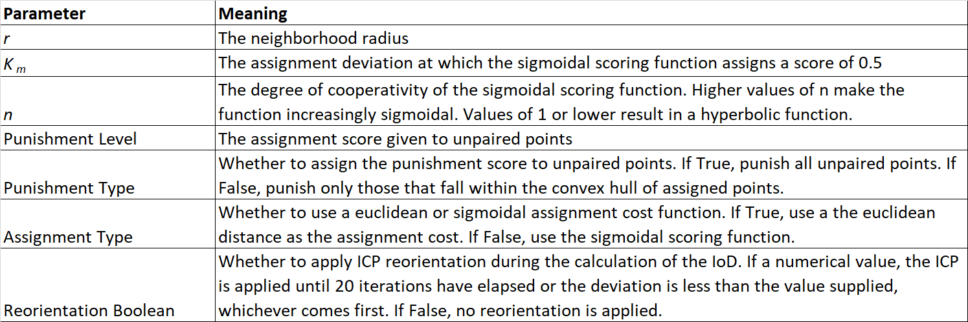

Table 2. Summary of classification results for each study area. Classification quality was assessed using Cohen’s kappa coefficient (κ) and accuracy. Differentiation of natural and planted trees using only the IoD displays moderate to high classification agreement, indicating that the IoD alone is sufficient to differentiate planted and naturally occurring tree stands. Differentiation of building types shows weaker agreement. For this purpose, the IoD alone may not be sufficient for acceptable classification quality but could be used to enrich more comprehensive classification methods.

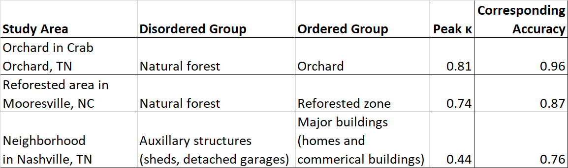

Table 3. Sensitivity evaluation of the IoD for Site 1 (orchard in TN) using a threshold of 0.8 and varying neighborhood radius (r) and midpoint of sigmoidal function (Km).

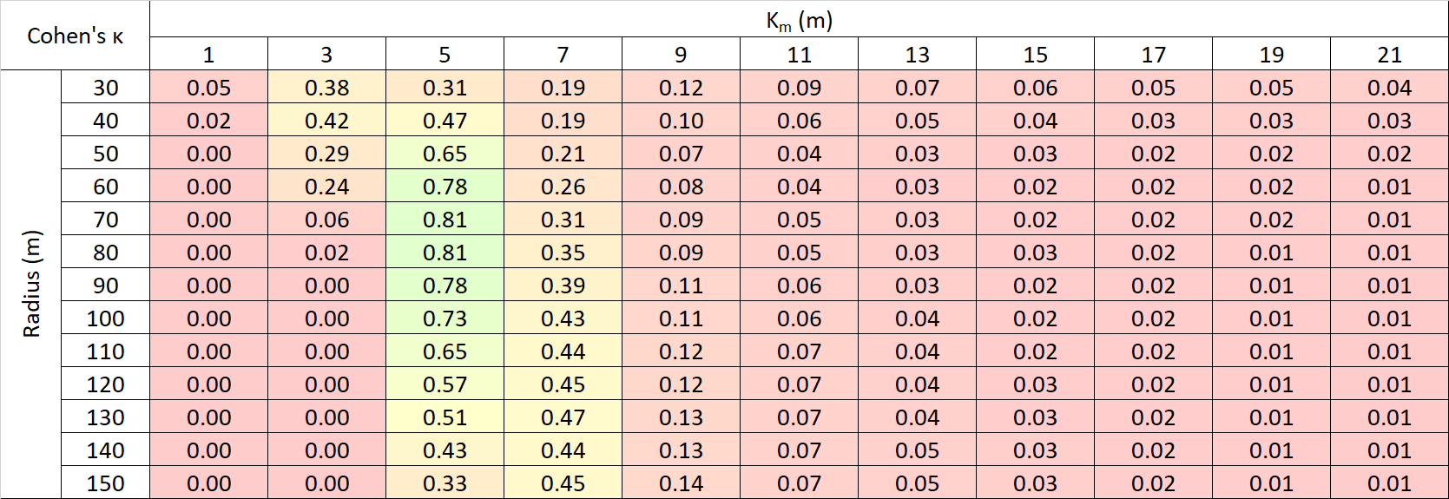

Table 4. Sensitivity test for Site 2 (replanted forest in NC) with an IoD threshold of 0.75.

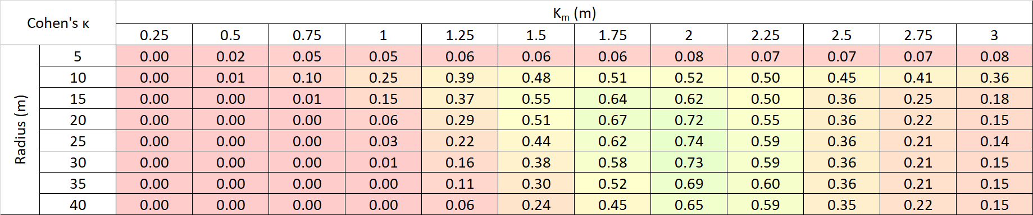

Table 5. Sensitivity test for Site 3 (building centroids in a neighborhood in Nashville, TN) with an IoD threshold of 0.70.

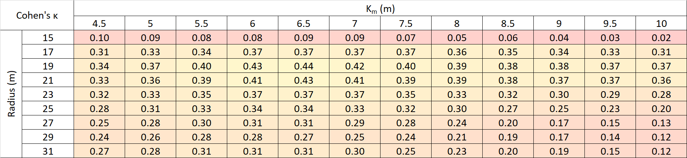



Figure 1. Generalized algorithm for calculating the IoD. Due to the heuristic nature of the algorithm, point set realignment, point pair assignment, and deviation scoring techniques can vary between implementations of the IoD.

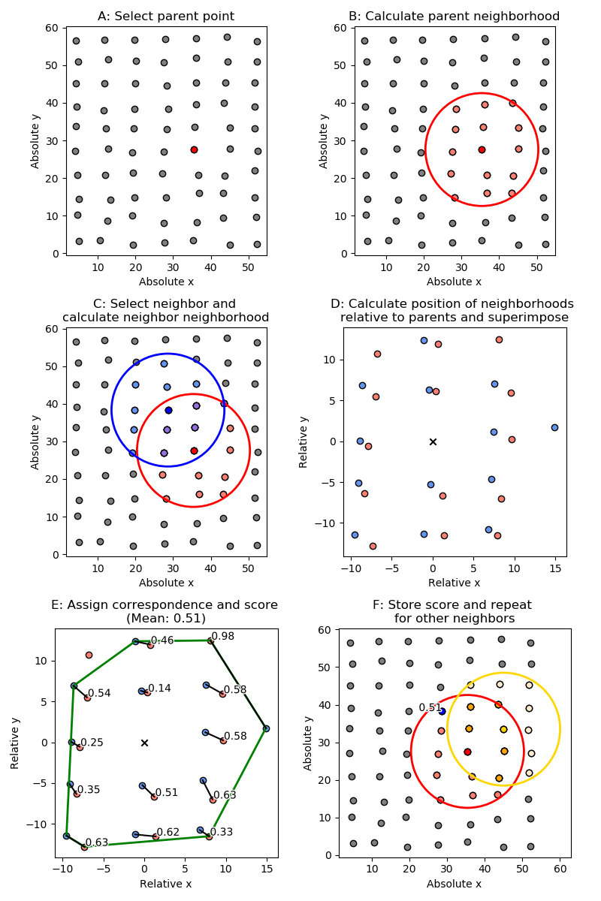

Figure 2. Illustration of the calculation of the IoD sub-score between two points. Given a parent point (A), its neighbors are selected (B). Similarly, given a child point its neighbors are selected (C). Both parent and child neighborhoods are converted from absolute to relative coordinate system (D). Each point in the parent set is assigned to a point in the child set (E). The process is then repeated by selecting another child point set (F). The IoD sub-score between two neighborhoods is the mean of the assignment scores between a parent point and every neighbor.



Figure 3. An example of a sigmoidal scoring function, $s= \frac{d^{n}}{{K_{m}}^{n}+ d^{n}}$, where d is the point-pair deviation, n is the function cooperativity and Km is the deviation midpoint. An n of 1 will create a hyperbolic function, while values greater than 1 will make the function increasingly sigmoidal. The value of $K_{m}$ is the value of d at which the score is 0.5; this is represented by the dashed green lines.



Figure 4. Visualization of the effects of using different cost functions on point assignment and IoD sub-score. The neighborhood radius is shown for both the red (parent) and blue (child) points in the upper left figure. The remaining three figures explore various point assignment methods and the calculated IoD.

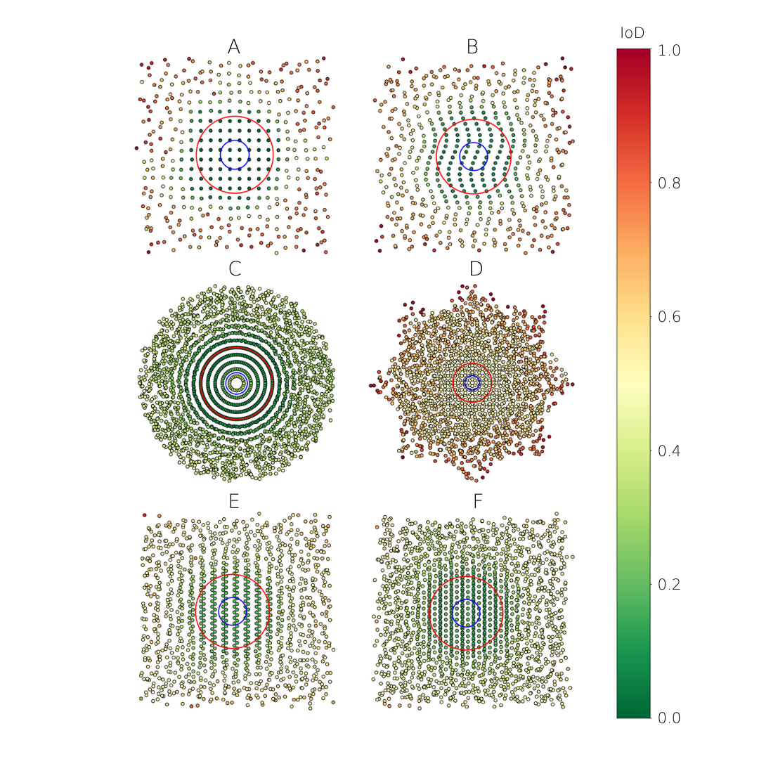

Figure 5. Results of theoretical evaluation of the IoD. The pattern is perturbed with random noise that increases in strength as a function of distance beyond the red circle, and the blue circle represents the neighborhood size. Multiple patterns were investigated: square grid (A), rectangular grid modified with a sinusoidal function (B), pattern formed by overlaying concentric circles with equal linear point densities (C), pattern formed by overlapping a square grid with a copy of the same grid rotated 45 degrees (D), pattern formed by overlapping two offset rectangular grids (E), pattern formed by overlapping three offset rectangular grids (F). No reorientation was applied.

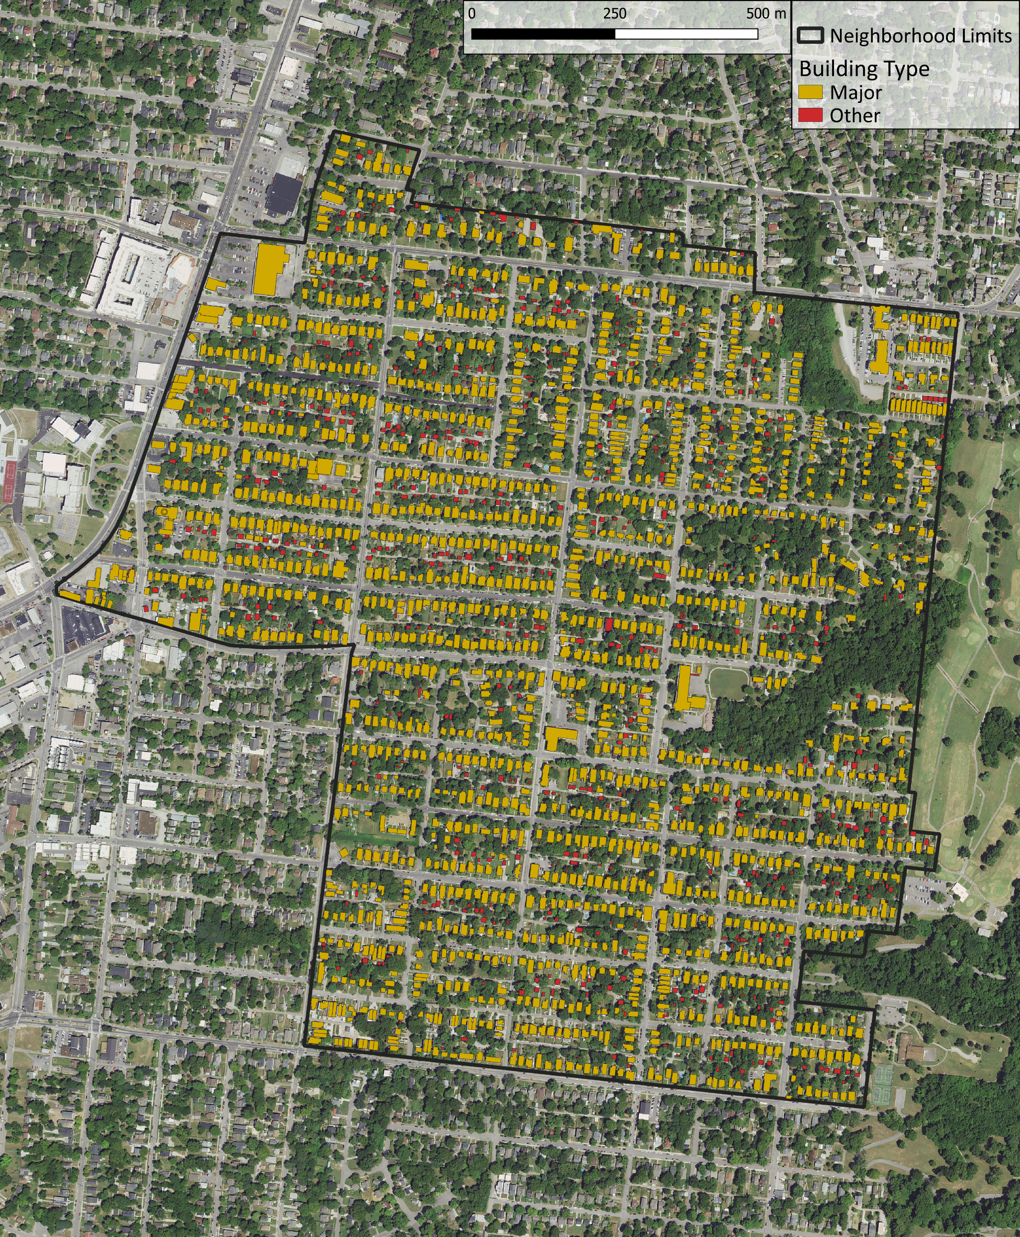

Figure 6. A map of building types in a neighborhood in Nashville, TN.

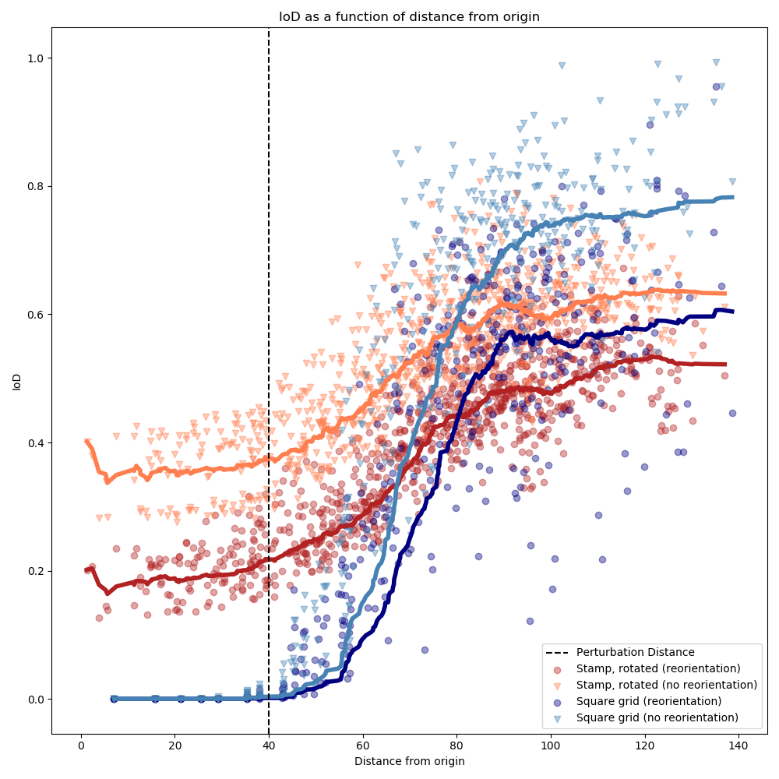

Figure 7. Illustration of the IoD as applied to various patterns with increasing noise beyond the perturbation distance as a function of distance. Point sets with a defined pattern (a repeating stamp or a continuous square grid) were created and then perturbed with noise of increasing magnitude beyond the perturbation distance. Points to the left of the perturbation distance are perfectly ordered, while those to the right are increasingly disordered. The IoD was applied both with and without realignment. A running average of the IoD for each pattern type is shown as lines.



Figure 8. Results from applying two versions of the IoD algorithm without and with realignment (left and right respectively) to a pattern that consists of a repeating wallpaper group (a “stamp”) that is continuously rotated. The pattern is perturbed with random noise that increases in strength as a function of distance beyond the red circle, and the blue circle represents the neighborhood size.

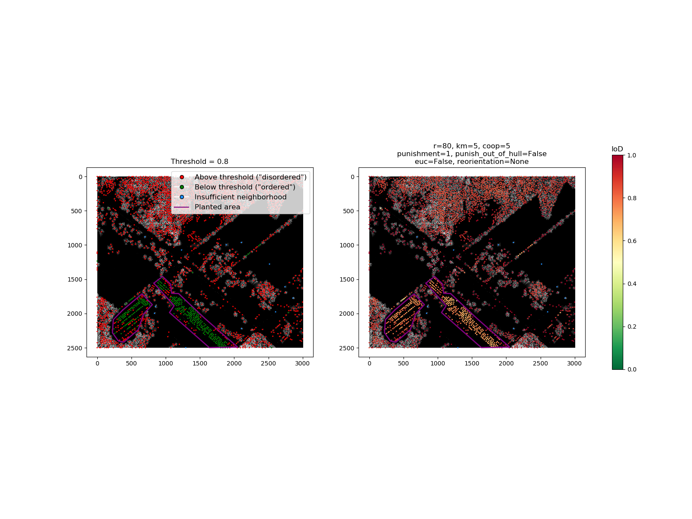

Figure 9. Results from applying the IoD to trees extracted from a DHM of an orchard near Crab Orchard, TN. Each point represents a tree crown. Axis units are meters. Trees with an IoD value above the threshold are classified as “disordered”, interpreted to be non-orchard trees. Trees with an IoD value below the threshold are classified as “ordered”, interpreted to be orchard trees.

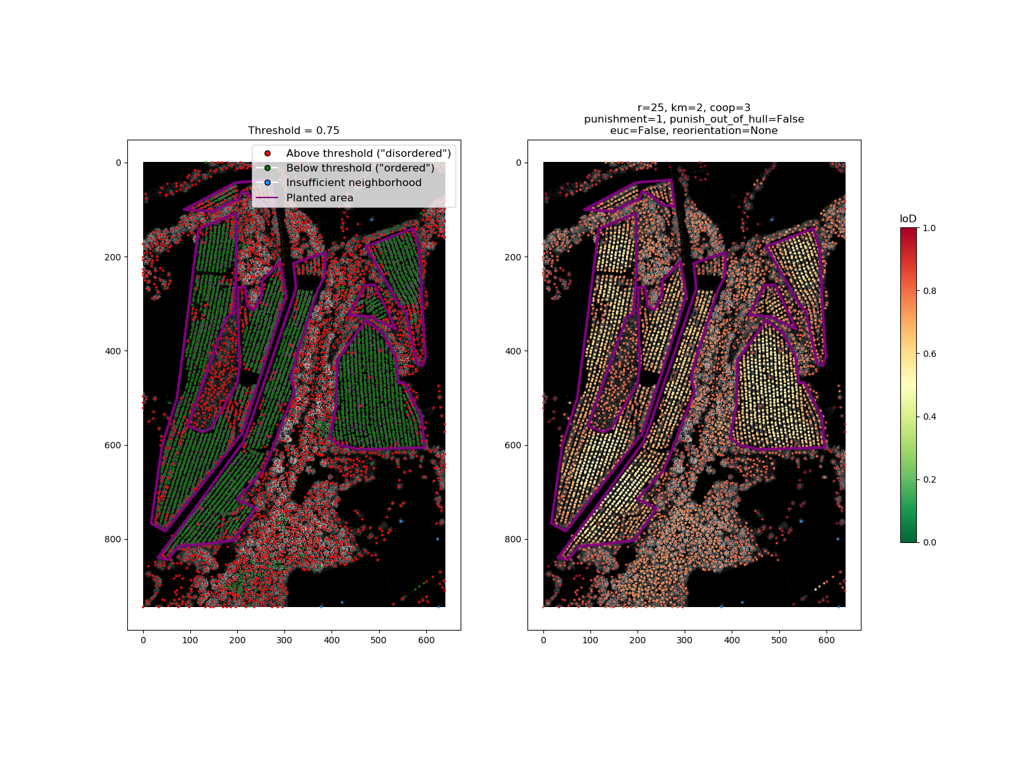

Figure 10. Results from applying the IoD to trees extracted from a DHM of a mixed planted and natural forest stand near Mooresville, NC. Each point represents a tree crown. Axis units are in meters. Trees with an IoD value above the threshold are classified as “disordered”, interpreted to be naturally occurring trees. Trees with an IoD value below the threshold are classified as “ordered”, interpreted to be planted trees.



Figure 11. Building centroids in Nashville, TN. On the right, the IoD is shown. On the left, classification results are shown for a threshold of 0.7. Buildings with an IoD below the threshold are classified as “major buildings”, such as houses (a negative response) and those above the threshold are classified as “other”, which is comprised of auxiliary buildings such as sheds and detached garages (a positive response). Axis units are in meters and correspond to the TN State Plane coordinate system.

# Acknowledgements

We thank Dr. Racha El Kadiri for her input and guidance while writing this manuscript.

# Funding

This work was partially supported by the Natural Resources Conservation Service (agreement number NR194741XXXXC005) and a Middle Tennessee State University, Undergraduate Research Experience and Creative Activity (URECA) grant.

# References

Aksoy, S., Yalniz, I. Z. & Tasdemir, K., 2012. Automatic Detection and Segmentation of Orchards Using Very High Resolution Imagery. *IEEE Transactions on Geoscience and Remote Sensing,* 50(8), pp. 3117-3131.

Antuono, M., Bouscasse, B., Colagrossi, A. & Marrone, S., 2014. A measure of spatial disorder in particle methods. *Computer Physics Communications,* 185(10).

Bailey, T.C & Gatrel, A.C., 1995. Interactive Spatial Data Analysis. New York: Wiley.

Besl, P. & McKay, N., 1992. A Method for Registration of 3-D Shapes. *IEEE Transactions on Pattern Analysis and Machine Intelligence,* 14(2), p. 239–256.

Boeing, G., 2019. Urban Spatial Order: Street Network Orientation, Configuration, and Entropy. *Applied Network Science.*

Cohen, J., 1960. A coefficient of agreement for nominal scales. Educational and Psychological Measurement. *Educational and Psychological Measurement,* 20(1), pp. 37-46.

Dong, P., 2000. Lacunarity for Spatial Heterogeneity Measurement in GIS. *Annals of GIS,* 6(1), pp. 20-26.

Haralick, R. M., Shanmugam, K. & Dinstein, I., 1973. Textural Features for Image Classification. *IEEE Transactions on Systems, Man, and Cybernetics,* SMC-3(6), pp. 610 - 621.

Isenburg, M., 2019. *LAStools - Efficient Tools for LiDAR Processing.* s.l.:rapidlasso GmbH.

Khan, M. M., Al-Yahyai, R. & Al-Said, F., 2017. *The Lime: Botany, Production and Uses.* s.l.:CABI.

Kuhn, H. W., 1955. The Hungarian method for the assignment problem. *Naval Research Logistics Quarterly,* pp. 83-97.

Liu, Y., Collins, R. & Tsin, Y., 2004. A computational model for periodic pattern perception based on frieze and wallpaper groups. *IEEE Transactions on Pattern Analysis and Machine Intelligence,* 26(3), pp. 354-371.

Loyd, C.D., 2010. Spatial Data Analysis: an Introduction for GIS Users. Oxford University Press, Inc. New York, U.S.A.

Lou, S. et al., 2016. Fusion of Airborne Discrete-Return LiDAR and Hyperspectral Data for Land Cover Classification. *Remote Sensing,* 8(1).

Momm, H., Easson, G. & Kuszmaul, J., 2009. Evaluation of the use of spectral and textural information by an evolutionary algorithm for multi-spectral imagery classification. *Computers, Environment and Urban Systems,* 33(6), pp. 463-471.

Nilsson, L. & Gil, J., 2019. *The Mathematics of Urban Morphology.* s.l.:Springer.

Oliphant, T. E., 2006. *A guide to NumPy.* s.l.:Trelgol Publishing.

Pauly, M. et al., 2008. Discovering structural regularity in 3D geometry. *ACM Transactions on Graphics,* 27(3).

Pedregosa, F. et al., 2011. Scikit-learn: Machine Learning in Python. *Journal of Machine Learning Research,* Volume 12, pp. 2825-2830.

Phiri, D. & Morgenroth, J., 2017. Developments in Landsat Land Cover Classification Methods: A Review. *Remote Sensing,* 9(9).

Remmel, T. K. & Csillag, F., 2003. When are two landscape pattern indices significantly different?. *Journal of Geographical Systems,* Volume 5, pp. 331-351.

Shekhar, S., Evans, M., Kang, J. & Mohan, P., 2011. Identifying patterns in spatial information: A survey of methods. *Wiley Interdisciplinary Reviews: Data Mining and Knowledge Discovery,* 1(3), pp. 193-214.

Swain, P. H. & Stephen B. Vardman, J. C. T., 1981. Contextual classification of multispectral image data. *Pattern Recognition,* 13(6), pp. 429-441.

Trias-Sanz, R., 2006. Texture Orientation and Period Estimator for Discriminating Between Forests, Orchards, Vineyards, and Tilled Fields. *IEEE Transactions on Geoscience and Remote Sensing,* 44(1020).

Zhen, Z., Quackenbush, L. J. & Zhang, L., 2016. Trends in Automatic Individual Tree Crown Detection and Delineation—Evolution of LiDAR Data. *Remote Sensing,* 8(4), p. 333.

1. Responsible for design, implementation and testing of algorithm, collection and processing of data, and drafting of manuscript.
2. Responsible for supervision of algorithm design, reproduction of results, manuscript drafting and revision.